Overview
The View transport booking page displays information about your travel bookings for attendance at medical appointments.
The screen displays upcoming travel bookings made by yourself, by health providers, and by DVA on your behalf. Your 20 previous travel bookings are also displayed.

The Transport bookings screen – Car bookings tab.
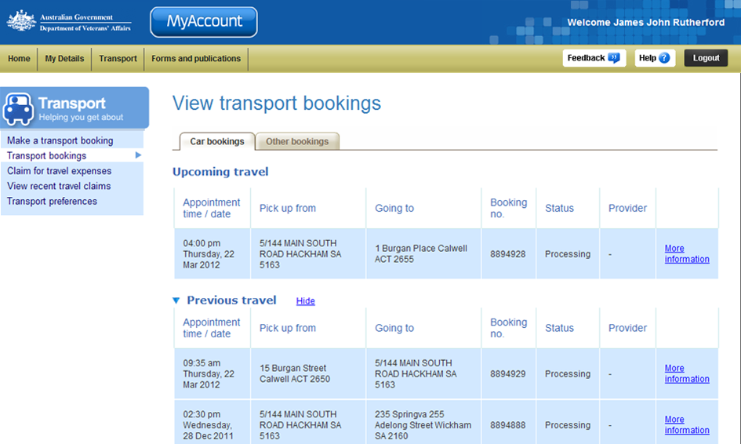
Upcoming travel section.
Previous travel section.
Transport bookings tabs
Transport menu.
There are two tabs on the Transport bookings page: Car bookings and Other bookings.

Car bookings
The Car bookings tab displays a list of your upcoming and previous travel bookings using authorised transport providers for taxi services. The information is presented in date order with the most recent booking displayed at the top of the list.
To display more information about a booking, such as contact numbers and specific instructions for transport providers, click on the More information link to the right of the booking.

Other bookings
The Other bookings tab displays upcoming and previous travel bookings involving long distance travel by air, coach, rail or ferry. These bookings are made on your behalf by DVA.

The Transport bookings screen – Other bookings tab.
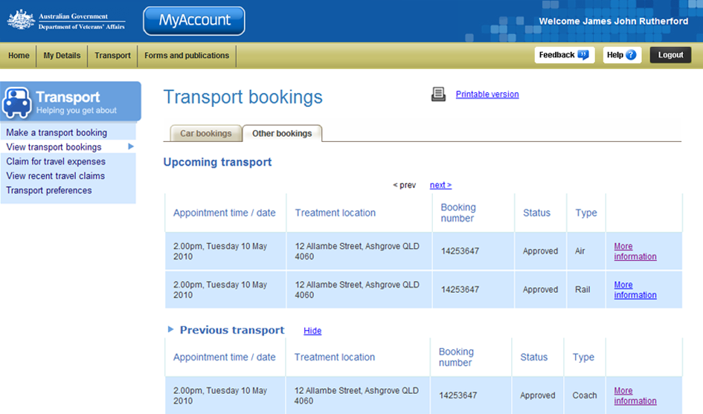
To display more information about a booking, such as contact numbers and specific instructions for transport providers, click on the More information link to the right of the booking.

Booking status
For each travel booking, one of six different status indicators is displayed.
Status | Description
Processing | The claim has been received. Department staff will check eligibility and allocate a transport provider.
Completed | A taxi has been dispatched or the travel has been completed.
Rejected | The booking was rejected. Either the travel booking was not eligible or there was some other reason the booking could not be approved.
Did Not Travel | Travel was not completed for this booking. The booking was approved but the transport provider indicated that they did not provide the transport.
Cancelled | The booking has been cancelled prior to the travel occurring.

Edit or cancel a booking
You can edit or cancel Car bookings displayed in the Upcoming travel section of the Transport bookings screen.
Other bookings (for air, coach, rail or ferry travel) cannot be edited or cancelled in MyAccount. Also, Car bookings cannot be changed after 3:00pm the day before the booked travel in MyAccount.
To make changes to these bookings, call DVA Transport on 1300 550 455 (metro areas) or 1800 550 455 (for regional areas).

To edit an upcoming car booking:
- For the booking you are interested in, click on the More information link to the right of the booking.

The View transport booking screen updates.
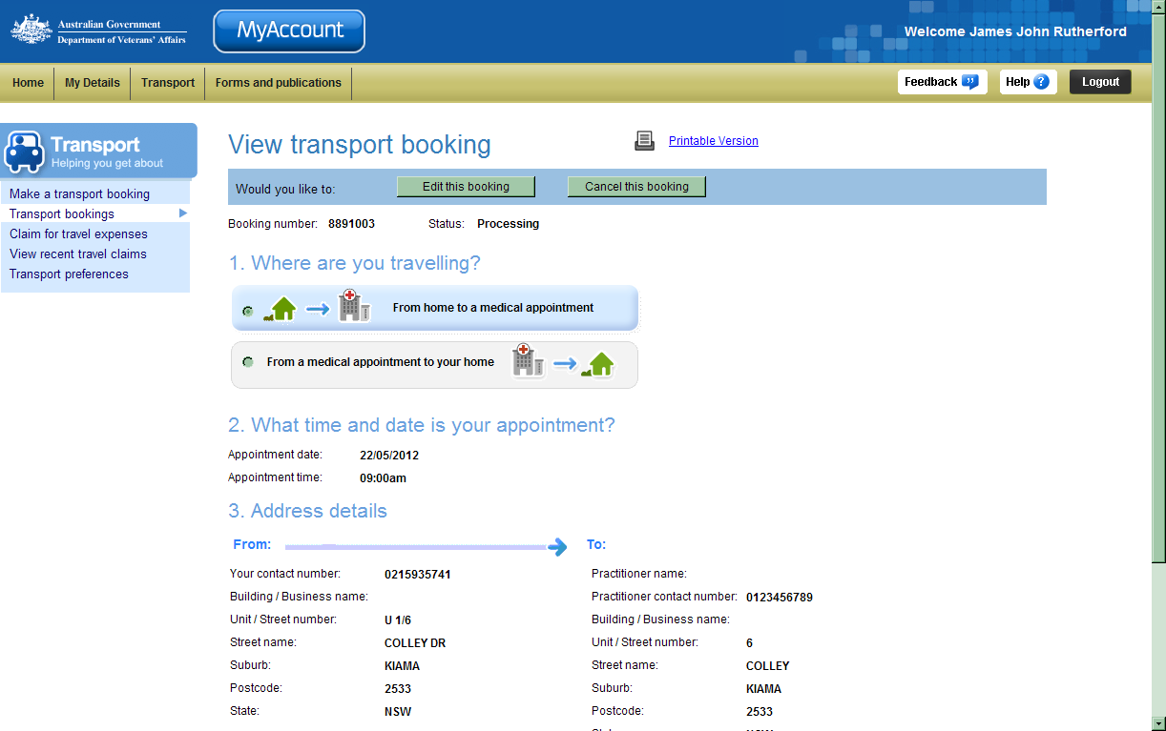
- To edit the booking, click on the Edit this booking button at the top of the screen. Go to Step 3.
- To cancel the booking, click on the Cancel this booking button at the top of the screen. Go to Step 5.

Edit a transport booking
- Make the required changes to the booking. Fields marked with a red asterisk (*) are mandatory.
- At the bottom of the screen, click on the Save button.

The View transport bookings screen updates.
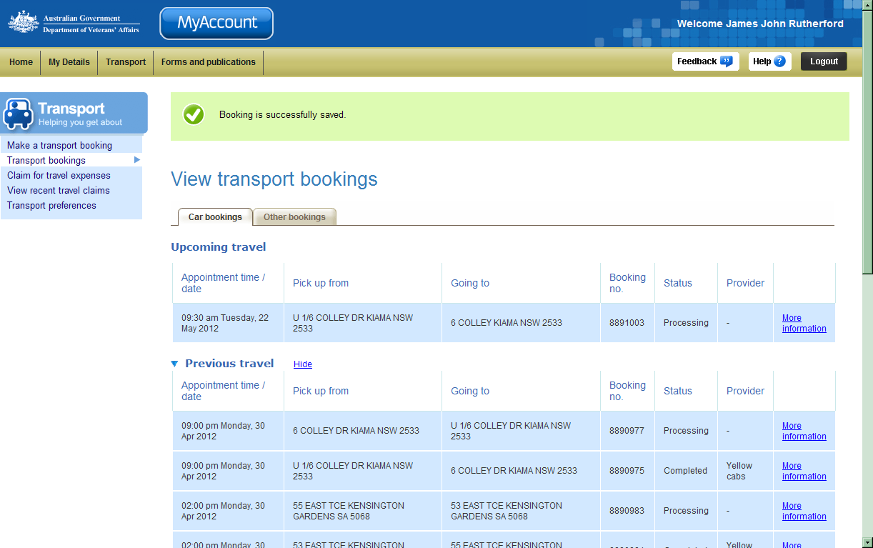
At the top of the screen a green success message states your booking has been successfully saved.
The updated booking details are displayed in the Upcoming travel section.

Cancel a transport booking
After you click on the Cancel this booking button, a dialog box displays.
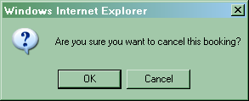
- To cancel the booking, click on the OK button.

The View transport bookings screen updates.
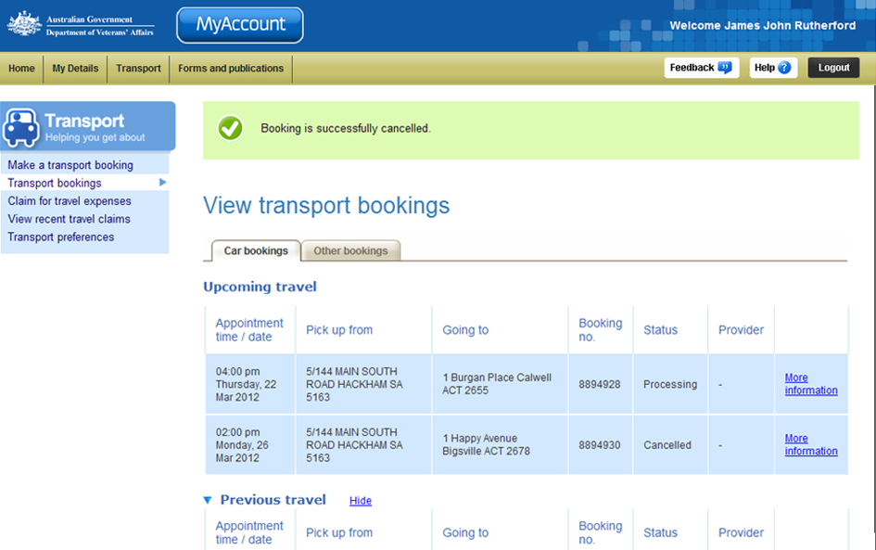
At the top of the screen a green success message states your booking has been successfully cancelled.
In the Upcoming travel section, the status of the booking has changed to ‘Cancelled’.

Other functions
 | To view another section or perform another transaction related to transport, click on a link in the Transport menu to the left of the page.
 | To get additional help with the View transport bookings screen, click on the Help button at to the top right of the page.
 | When you are finished using MyAccount, to log out and finish using the service in a secure way, click on the Logout button.

